Indexing the Garrison Folders

I’ll be the first to admit that I only had a passing knowledge of the scope of New Orleans District Attorney Jim Garrison’s investigation into the JFK assassination through its New Orleans aspect. His book ‘On the Trail of the Assassins’ was the very first book I owned on the subject. The story is also told in Oliver Stone’s ‘JFK’ and is still, to this day, it is the only instance of the case being tried before a court of law. As my interest grew in the topic, I so did my awareness of the controversy that continued to orbit the legacy of Garrison’s investigation. The lack of avenues of inquiry into Carlos Marcello / New Orleans mob, perceived targeting of homosexuals in New Orleans, using sodium pentothal in interrogations, infiltrations to sabotage the investigation to name a few. It was thanks to the works of Mellen (Farewell to Justice) Di Eugenio (Destiny Betrayed) and Russell (The Man Who Knew Too Much) that I began to scratch the surface of the intrigue in New Orleans – before and after the JFK assassination.

In February 2022, I emailed Len Osanic on the back of a conversation he had on his podcast, Black Op Radio with researcher Paul Bleau. Up until that point I was already aware of the great work Paul had been putting out around the Fair Play for Cuba Committee and hearing him refer to how much of his source information came from the Garrison folders, I reached out to Len to ask for access to them as well.

Receiving the folders, I was taken aback by the diversity of topics that were contained within them. Multiple folders with titles containing ‘Clay Shaw’, ‘David Ferrie’, ‘Guy Banister’, ‘Lee Oswald’. However, the more I delved into the folders, the more duplications and cross-categorising of documents I found within them. A good example is how records on Clay Shaw’s finances are filed within the ‘Miguel Torres’ folder. This is not a criticism of the original curator of the Garrison folders. In fact, the story goes that these folders (the last remaining of his office’s collection) were only just saved from being destroyed by Garrison DA predecessor and detractor, Harry Connick before being anonymously donated to Len Osanic.

What will surprise people that acquire the Garrison folders is not only their diversity of topics but how much time they span; from 1947 to 1991. The point being that Garrison amassed a massive catalogue during and after his investigation in the 60’s proving that his interest in the JFK assassination never waned right up until his death in 1992. It was out of honor and respect for Garrison’s admirable devotion to seeking the truth behind the JFK assassination and the sacrifices he made that I remained motivated to complete the gargantuan task of creating a simple name index for them.

Having acquired the Garrison folders, in April 2022, I opened up a spreadsheet in Microsoft Excel and started recording names within the first folder ‘Additional Thornley Material’ and like Forrest Gump, I just kept on going by recording names. I soon reached out to Paul Bleau to let him know I was embarking on this and that I would let him know of anything of interest that I found. I asked him to reach back out to me for any facets of the JFK assassination that I might keep an eye out for as I went through the folders as well. At around the same time, about 1,000 lines deep into the index, I emailed Jim Di Eugenio to ensure that I wasn’t reinventing the wheel with anyone else’s work either.
He advised that Paul Veer had compiled a rough and very general index only. Onward I stepped in my epic task.

The Garrison Folders consists of 171 folders that include 12,818 scanned PDF pages taking up 2GB of space. Newspaper cuttings, Garrison office memos, interrogations, letters, FBI, DPD, Secret Service, Warren Commission testimony transcripts. I must stress that I did not read every page word for word – I simply scanned over them to look for names and context. I deliberately did this to stick to my overarching purpose of the exercise. To collect names and list them.
And it soon occurred to me that I could potentially farm out some folders to others to help with building the index but considering the numerous instances of duplicate documents that I had already picked up in the folders, I knew that it was really only something I could complete as I was already able to recall if I’d indexed a document or not. I am sure that this will be one of the positive outcomes for indexing Garrison’s folders - to organise all duplicates out of them to make the information as clear and easy to access as possible.

To ensure the quality of the index, I set myself some very clear guidelines to complete it.
- Its primary purpose should be an index of names and their location within the files. Any additional context that I could glean was bonus and should also be listed.
- Scanning not reading would enable me to build the index over a realistic period of time to ensure that my memory would be fresh for weeding out duplicate documents.
- Consistency would be key. Naming convention, capturing broad context and time all needed consistency in formatting and categorising.
- The exercise of indexing the Garrison Folders was not about trying to find ‘silver bullet’s or ‘skeleton’s in the closet’ that would solve the JFK assassination once and for all. It would just be a resource to help those much more knowledgeable on the case than I do that.

The last point is perhaps the most important for both completing the index but for how I intended it to be used. Most reasonable scholars of the JFK assassination will surely appreciate that there was never likely anything confined to paper that points directly to who set up Lee Oswald, killed President Kennedy, why it all happened as well as how it was covered up. If anything like that existed, the passage of time and an overarching apparatus to control the narrative of the case, for the sake of national security etc etc…would have seen it destroyed long ago. But what is true is that most breakthroughs in the case ever since have come from researchers piecing together and corroborating documents and evidence. This is an important point for all users of the index to keep in mind because as I was completing it, I only came across a handful of tidbits that I did not know about the case. But that is just me – everybody’s level of knowledge on the JFK Assassination is their own. This is why I sought to keep the index as simple and easy to use. So anyone from new arrivals to the JFK assassination to its most seasoned and expert of scholars could use it and find and corroborate information.

So, how do those with the Garrison Folders best use the index? There’s a few ways, as intended, to ensure its ease of use for people of all knowledge and interest levels. It is a simple spreadsheet that can have filters easily applied to each of its columns:
- Who
- Folder Name
- Page Number
- Where
- Organisation/Title/Alias
- When
- General Context (What)
- Context Additional
- Context Additional

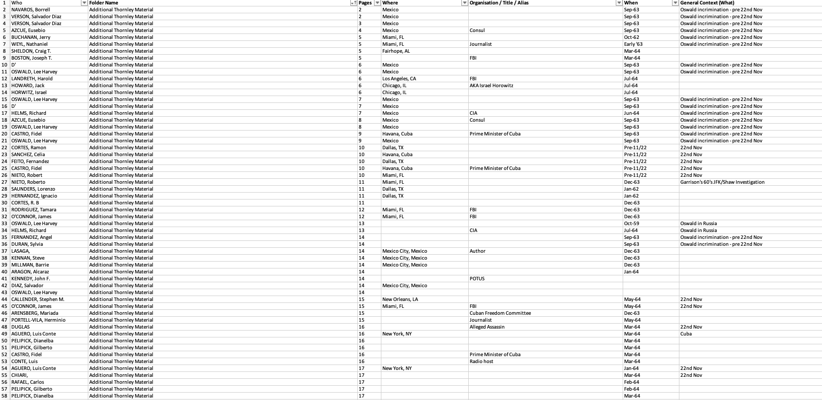

If a user is particularly interested in researching a person, filtering out their name in column A will bring their name up along with reference to every other file and context that they appear in within the files. The same applies for all other columns right through until general context where a user may wish to gather all references across the files in relation to a particular facet from Oswald’s vaccination records, Ferrie’s Library card, the Bilderberg Group to the RFK and MLK assassinations.

Users general interest in history will be also sated by the Garrison Folders and this corresponding Index as there are many news article clippings that provide a glimpse into the perspective of both mainstream and alternate media sources and publications during the time. And with the passage of time, it is interesting to note how astute some reporting was but also how prescient it would turn out to be when subsequent world history and current affairs is considered.

Before I embarked on building the index, I had been the beneficiary of the hard work of many scholars and truth seekers. And with thanks to the recent examples of perseverance in Paul Bleau and his invaluable work on the FPCC and Garrison aspects, Bart Kamp for his digitising of Malcolm Blunt’s extensive records collection as well as the openness of Len Osanic / Black Op Radio and Jim Di Eugenio, I felt compelled to do my bit too.

My hope for the index is two-fold - that scholars of all levels will use it to either validate their research or, better still, uncover missing pieces that prompts new lines of enquiry. I would also like it to be a source of inspiration for others wishing to contribute to the research community. History should never be immune from distillation. It should be examined without preconceived outcomes or agendas. Let how this index was compiled by one person wishing to their part also be an example of this.

Paul Abbott
September 2023

